Procedure to develop web application having jsp page using Eclipse IDE

===================================================

Step1: create dynamic web project in eclipse IDE.

(JSpApp3-Allscripting Tags)

Step2: add jsp page to src/main/web app folder

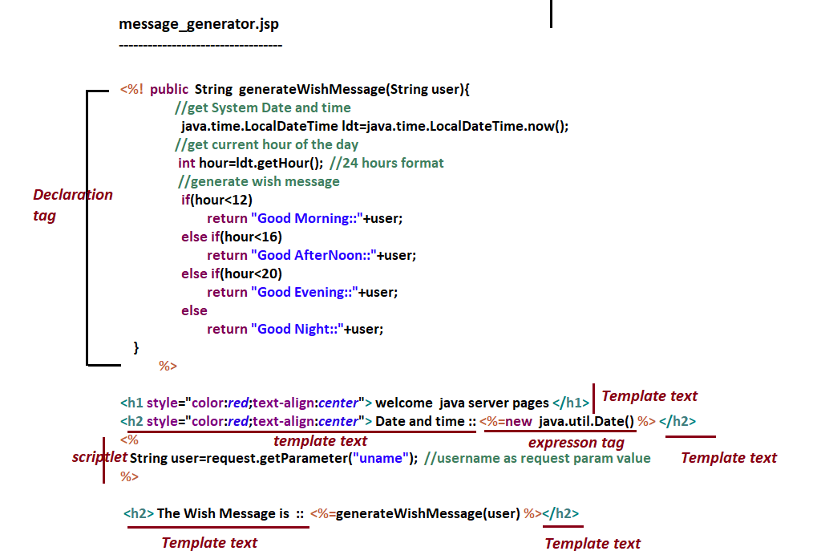

Step3: Run the app

Right click on Project 🡪run as 🡪 Run on server.

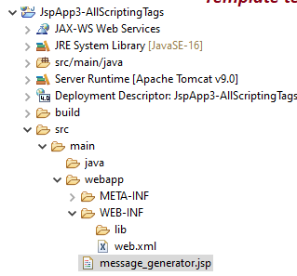

If the jsp page is executed through eclipse IDE. Then its jsp equalent servlet (JES) will be generated in the following location:

